**Lecture 11-13-23**

**For due date, see CANVAS**

**Problem One**

Create a program (i.e. tip calculator, risk assessment) using functions with the four critical elements mentioned in this week’s video.

Include DOC STRING calls for each function.

Make sure each section has adequate comments.

**INSERT SCREENSHOTS OF CODE AND OUTPUT HERE**

**Problem Two**

Create two lists of random bowling scores.

THEN, use the “**charges**” function to attempt to alter the scores, such as appending the list with another piece of data.

IF the data is changed, then take the random bowling scores and PROTECT THEM.

Re-run the scores through this function to ensure you have, indeed, protected them.

**INSERT SCREENSHOTS OF CODE AND OUTPUT HERE**

**Problem Three - complete following WORK TICKETS**

**WORK TICKET 1**

**Use the following coding scheme for arbitrary arguments from lecture:**

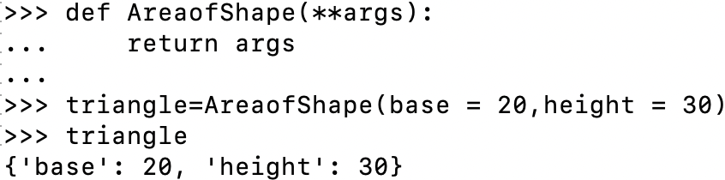

Use the above arbitrary argument form to complete below customer request:

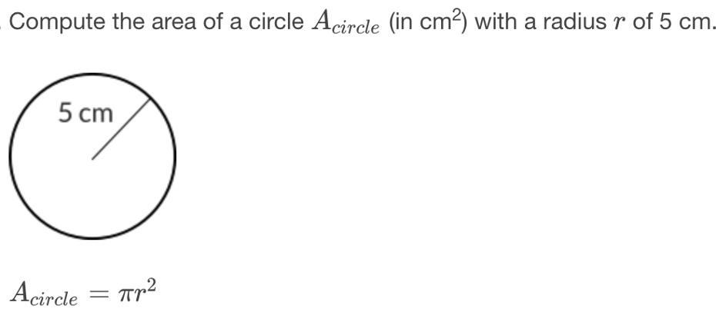

**WORK TICKET 2**

Use the ‘arbitrary argument form’ mentioned in **Work Ticket 1** to complete below customer request:

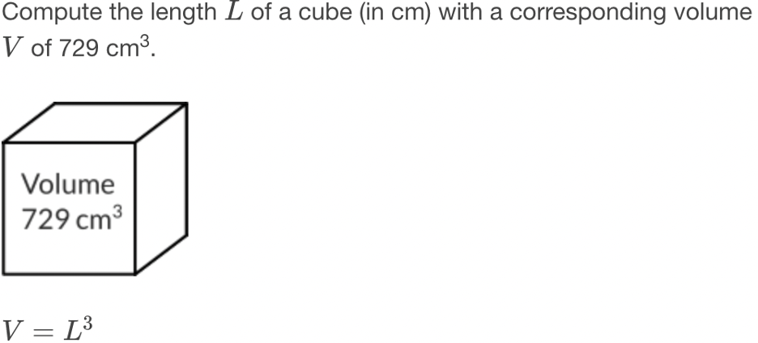

**WORK TICKET 3**

Use the ‘arbitrary argument form’ mentioned in **Work Ticket 1** to complete below customer request:

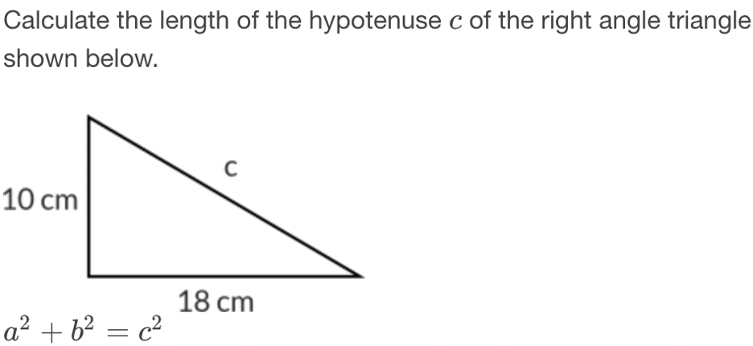

**WORK TICKET 4**

Use the ‘arbitrary argument form’ mentioned in **Work Ticket 1** to complete below customer request:

Solve the below problem.

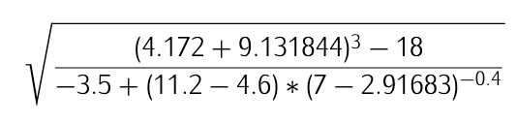

**WORK TICKET 5**

**What is the output of the following pieces of code, and WHY?**

**A.** **TRY to PREDICT the code WITHOUT running the code**

**B.** **RUN the code and PASTE the results**

**C.** **Were they what you expected? Why and/ or Why Not?**

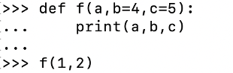

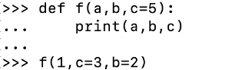

**INSERT SCREENSHOTS OF CODE AND OUTPUT for all work tickets HERE**

**Problem Four**

Create a SIMPLE program using a lambda.

**INSERT SCREENSHOTS OF CODE AND OUTPUT HERE**